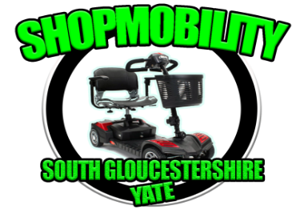
TELEPHONE: (01454) 868718
MOBILE: 07999 574474
Email: shopmobilitysouthglos@yahoo.com Registered Charity No. 1107379

Shopmobility (South Gloucestershire) is a small non-profit making charity and providing a service to people with mobility problems for 16 years. We are based at Yate library within Yate shopping centre

We are funded by the West of England Combined Authority, South Gloucestershire Council, local town and parish councils, local councillors, grant providers and donations from our members.

We are supported by Yate shopping centre who provide us a garage to charge and store our scooters and by Pearce brothers or service our mobility scooters at a reduced rate.

Our services seek to improve independence, quality of life, and social engagement to enable people to access shops, services, places and meet with others.

Reducing social isolation and ability to get out of the home environment is often cited as one of the most significant benefits in using our service.

We can give impartial advice for those deciding to buy their own mobility scooter and can provide wider information on other agencies that may be able to offer support.

We endeavour to identify people with mobility problems most at risk of social isolation who may require additional support to access our service.

Community transport is able to transport people to Yate shopping centre for those unable to drive or walk. We can meet people with a mobility scooter when people arrive by community transport or by car within the centre.

Being met with a mobility scooter can eliminate difficulties people may experience lifting and assembling their own mobility scooter from their car dependence on having a relative undertake this task for them.

We recognise the important role that relatives, friends, neighbours play in supporting people lacking confidence to access our service and supporting people use a mobility scooter for the first time.

We are mindful that people who are unable to drive or have limited access to a car may feel particularly isolated.

We recognise the emotional impact of sudden loss of health through accident or illness and how this can be a significant factor in causing lack of confidence and social isolation.

Those most isolated may experience more significant physical and mental health issues which can be compounded by limited support networks.

People may feel lonely or isolated and lost the confidence to venture due to the impact of the pandemic and added difficulties associated with a physical or hidden disability.

Accessing services with a mobility scooter from more rural locations can be problematic or impossible due to distances involved, risk of battery failure, lack of pavement and exposure to poor weather conditions.

There are subsequently a significant number of people who would like to own a mobility scooter but are unable to use one in the area in which they live or store within the home.

We offer limited longer-term hire of mobility scooters and wheelchairs for those wishing to go away on holiday, having relatives staying in the area or whilst recovering from an accident or operation.

Some people will try a mobility scooter to develop confidence before deciding whether to buy their own.

There is a small charge for longer term hire but no charge for daily hire to those with a bus pass who live in the South Gloucestershire area.

We are looking for volunteers with a caring nature and reasonable fit to support us.

Should you require further information we can be contacted on 01454 868718
or emailing: shopmobilitysouthglos@yahoo.com

Sheridan Crew
(Project Manager)
Shopmobility South Gloucestershire

